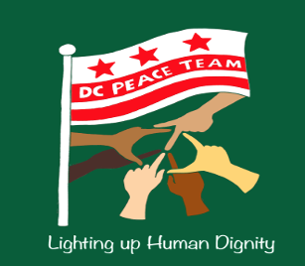
DC Peace Team
Cultivating Nonviolent
Peacemaking and Resistance

How to Imagine a Peace Team!
A peace team is committed to cultivating the habits and skills of nonviolence, with a particular focus on unarmed civilian protection and accompaniment. By creating a nonviolent community, we can unleash the power of civilians to better resist injustice and build a more sustainable just peace.
Some Key Questions:
What are the gifts, strengths, and existing mechanisms in your community regarding safety, protection, and accompaniment?
What are the primary and persisting needs in your community related to safety, protection, and accompaniment?
What are the primary and persisting types of violence that generate destructive conflict? Consider direct, structural, and cultural types.
Some Initial Steps:
- Meet with key stakeholders from diverse perspectives and neighborhoods to help answer the above questions and to identify who might value or have interest in a local peace team.
- Set up a discussion with those who may be interested in a local peace team to discuss the community assessment information and to determine who would like to work on a brief vision and focus statement for the peace team.
- Come up with a vision and focus, it can be a short few sentences. See example here.
- Choose a name
- Share with the team about the Shanti Sena Network and the support system available. Join their list-serve and add your team to their webpage.
- Develop a plan and set initial priorities based on the community assessment
- Set a regular meeting time, such as once a month for the core group.
- Build capabilities by having participants take core training modules such as nonviolent communication, bystander intervention and de-escalation, unarmed civilian protection and accompaniment, as well as restorative circles. Take training to learn how to lead such training as needed.
- Through the experience of working together, identify key roles to provide structure, organization, and communication, such as team coordinator, trainers, website/social media, UCP deployment coordinator, volunteer coordinator, etc.
- Develop committees as capacity and programs grow; such as a training committee to set the training calendar and strategy; an unarmed civilian protection committee to scale up UCP practices in the community; a measurement/evaluation committee to assess impact and ways to improve; an outreach/communications committee to share programs and generate new projects; a grants/donor committee to build resources, etc.
- Continue to build partnerships in the community with one-on-one meetings, showing up at events, and group meetings.
- If you desire assistance with becoming a 501c3, you can contact the DC Peace Team.
- Imagine, have fun, be creative, and keep thinking outside the box!

